Sophi Taylor Building,
Park Farm, Villa Road, Impington, Cambridge CB24 9NZ

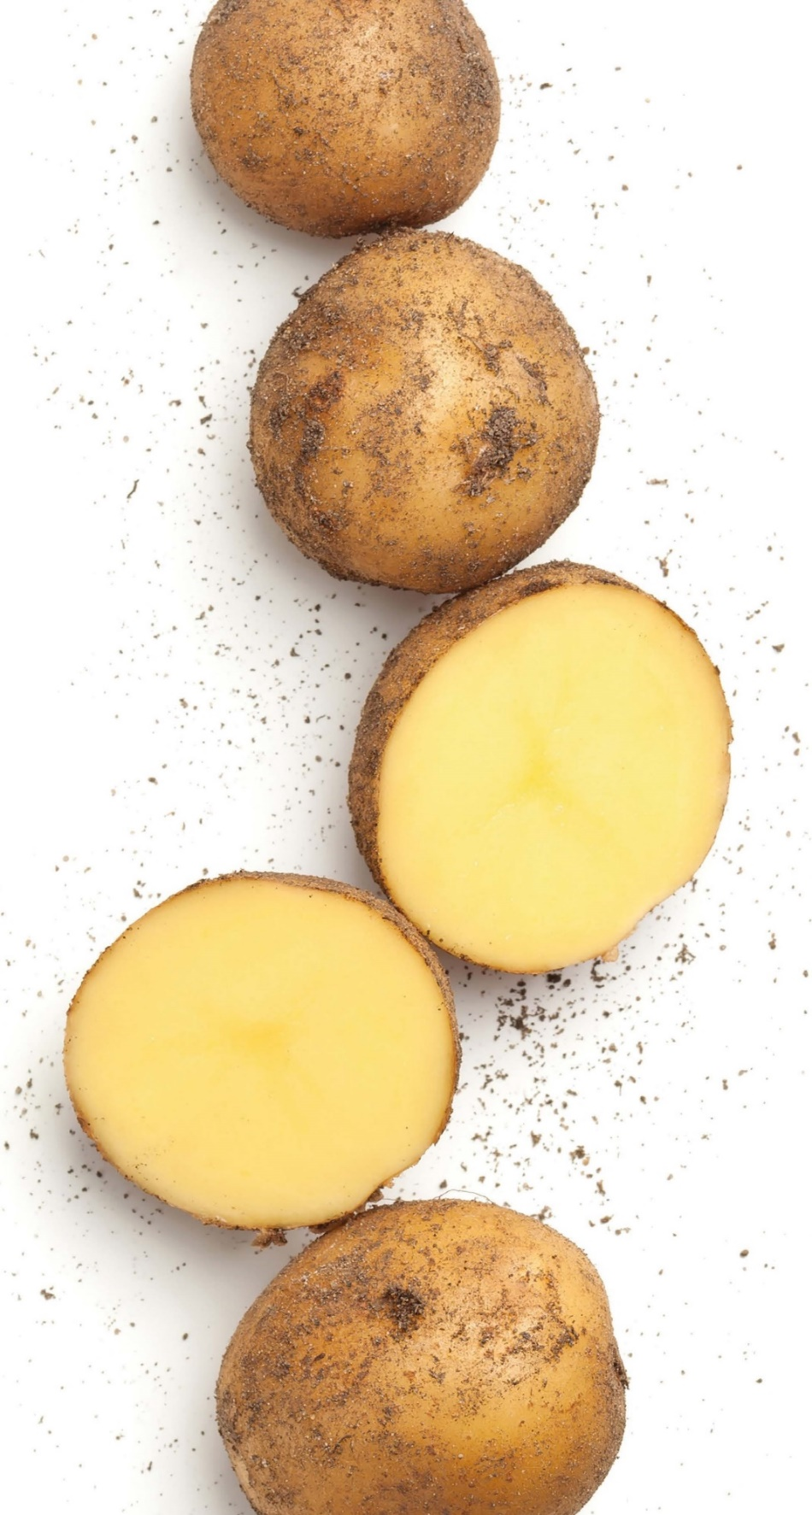
Summer Members Day - Tuesday 14th June 2022

10:30 | Meet at the Sophi Taylor Building
11:00 | Welcome and Project discussion of experiments
12:50 | Lunch
13:45 | Afternoon tour of experiments
15:30 | Leave from field

The Summer Members Day is an opportunity to hear at first hand details of the wide range of potato experiments and projects being carried out in Cambridge and elsewhere. Projects discussed will include storage, blackleg and wireworm. There is also the opportunity for discussions on all aspects of potato production.

BASIS points will be available.

Members are welcome to bring along a guest who may be interested in joining CUPGRA to the Members Days, but only if they have not been a guest in the past.

If you wish to book multiple people, in the online Shopping Basket page, from the link below, please click "Add Attendee".

CUPGRA Summer Members Day June 2022 | University of Cambridge

The on-line booking site is the preferred option for booking. If you wish to pay by cheque, please complete the reply slip below and return it together with your cheque made payable to ‘Cambridge University’ no later than 10th June 2022 to Kate Pottle.
-------------------------------------------------------------------------------------------------------------------
I shall attend the Summer Members Day on Tuesday 14th June 2022 to be held at the Sophi Taylor Building.
Name |  | Company Name
Email address
Telephone Number
I wish to bring |  | as my guest
£10 Lunch Yes/No |  | Dietary requirement
Access requirements
A receipt is required
Please note: Payment for lunch only, not event. Lunch must be pre-ordered and pre-paid.

Regards Kate
On behalf of CUPGRA

